GIT Challenges

Git Challenges
- Resolve Merge Conflicts
  - Create a merge conflict intentionally (two users editing the same line).
  - Resolve the conflict and push the changes.
Goal
Two branches modify the same line, causing a conflict.
Step 1: Create a file
echo "This is the original line" > conflict.txt
git add conflict.txt
git commit -m "Add conflict file"
Step 2: Create branch 1
git checkout -b user1
Change the file:
echo "Changed by User 1" > conflict.txt
git add conflict.txt
git commit -m "User 1 changes"
Step 3: Create another branch from main
git checkout main
git checkout -b user2
Change the same line:
echo "Changed by User 2" > conflict.txt
git add conflict.txt
git commit -m "User 2 changes"
Step 4: Merge
git checkout main
git merge user1
Then:
git merge user2
You'll get:
CONFLICT (content): Merge conflict in conflict.txt
Automatic merge failed
Check:
git status
Step 5: Open the file
You'll see something similar to:
<<<<<<< HEAD
Changed by User 1
=======
Changed by User 2
>>>>>>> user2
Choose the version you want, for example:
Changed by User 1 and User 2
Then:
git add conflict.txt
git commit -m "Resolve merge conflict"
Push:
git push origin main
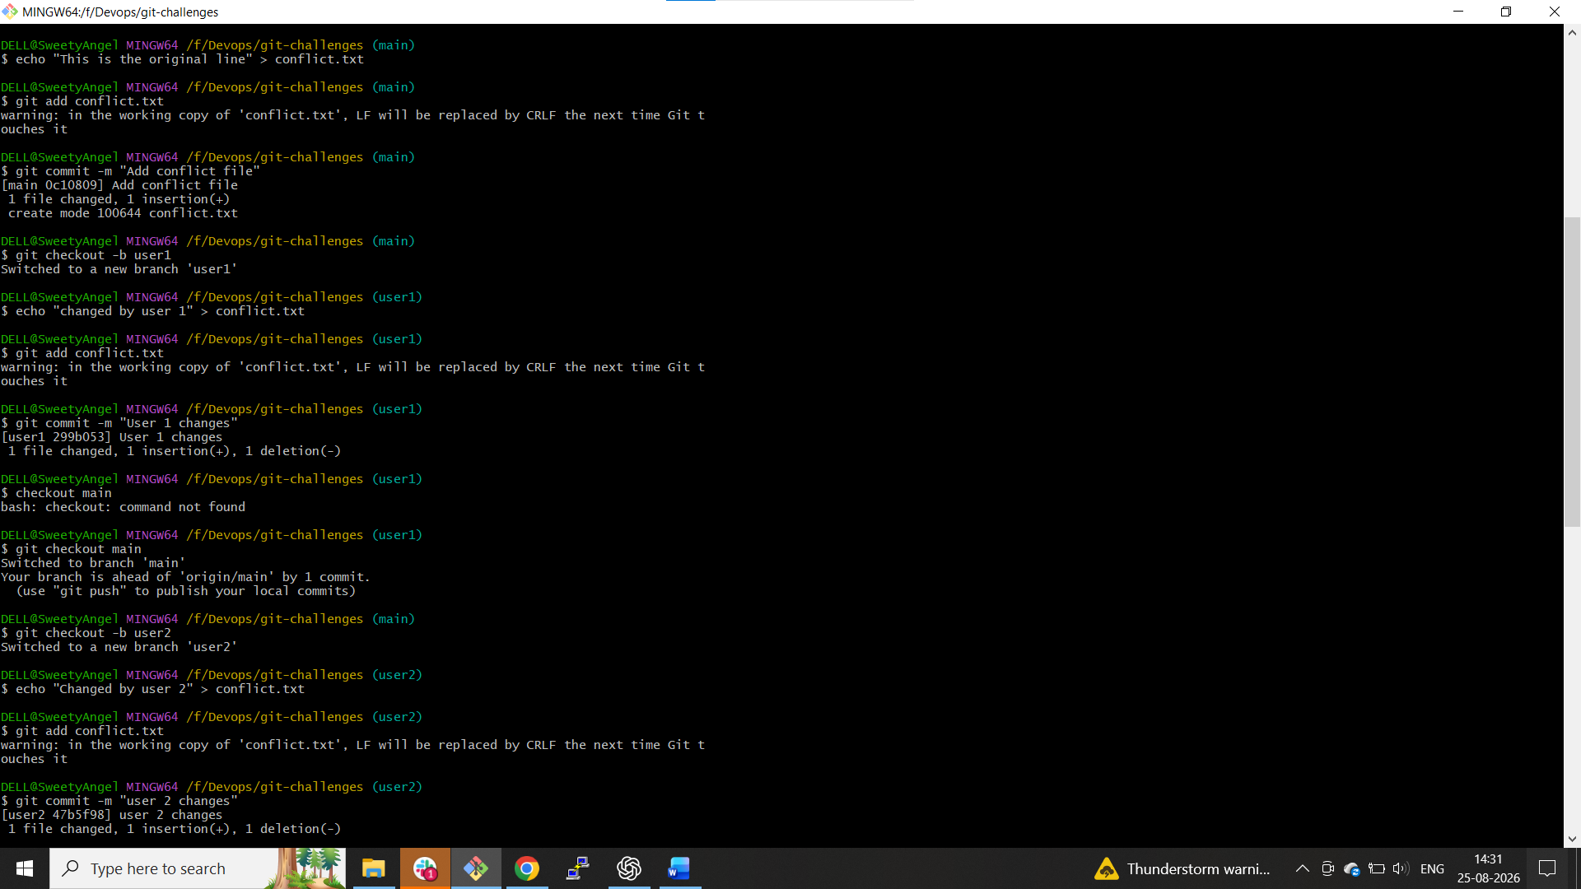
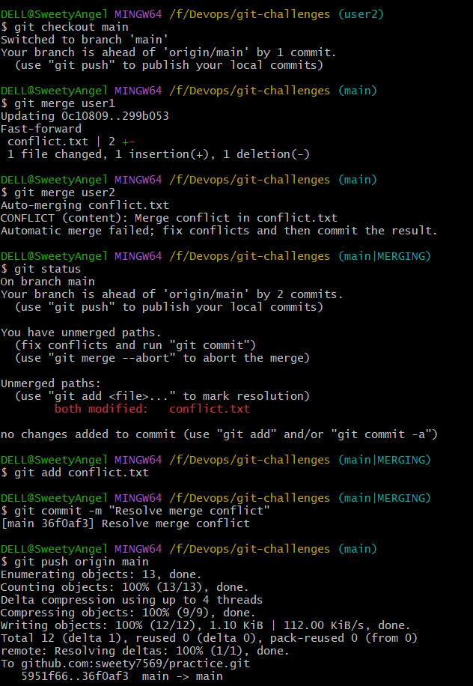

- Recover Deleted Branch
  - Delete a local branch and then recover it using the reflog.
Create a branch
git checkout -b recovery-test
Make a commit:
echo "Recovery test" > recovery.txt
git add recovery.txt
git commit -m "Add recovery test"
Find the branch:
git branch
Delete it:
git checkout main
git branch -D recovery-test
Now:
git branch
The branch is gone.
Recover using reflog
git reflog
Find the commit belonging to recovery-test.
Example:
abc1234 HEAD@{2}: commit: Add recovery test
Recover:
git branch recovery-test abc1234
Check:
git branch
You recovered the deleted branch.
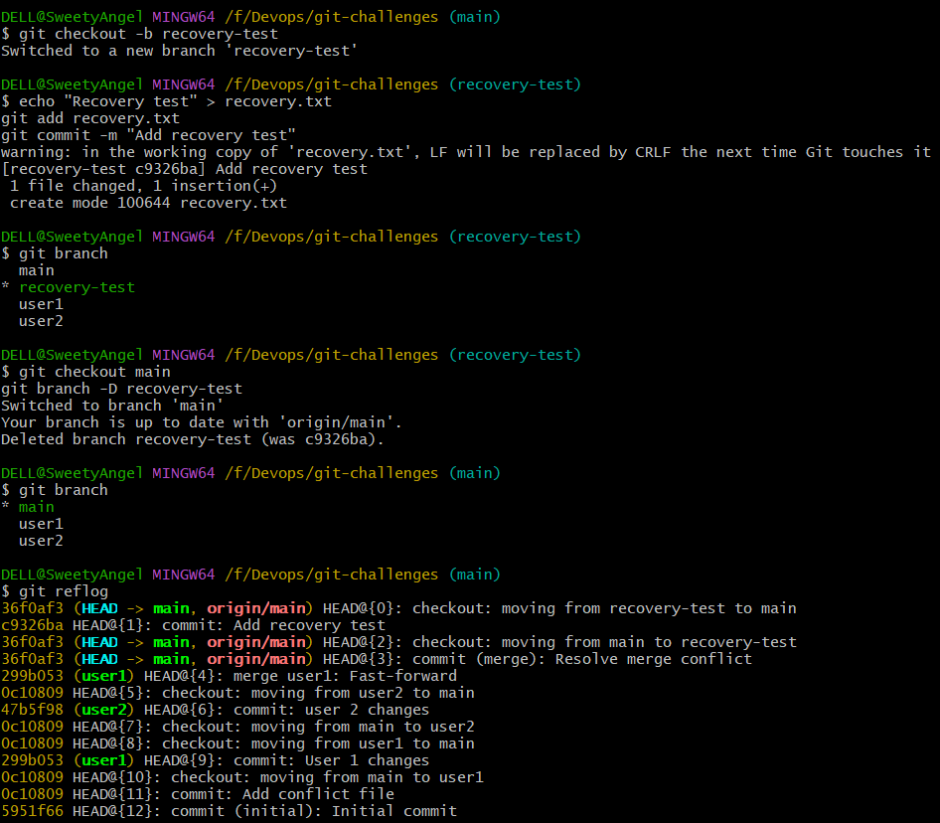
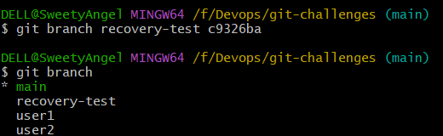

- Undo Wrong Push
  - Push a wrong commit to GitHub, then undo it without losing history.
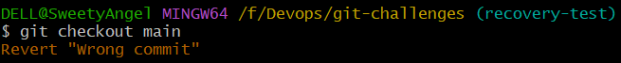
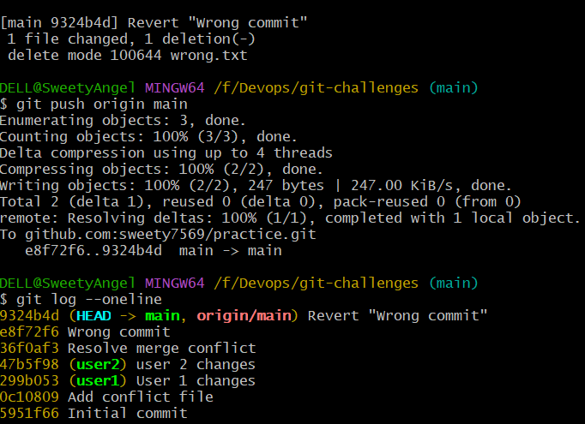
- Amend a Commit
  - Make a commit, then add a missing file to it usinggit commit --amend.
Create a file:
echo "First file" > file1.txt
git add file1.txt
git commit -m "Add first file"
Now you realize another file was missing:
echo "Second file" > file2.txt
git add file2.txt
Amend the previous commit:
git commit --amend --no-edit
Check:
git show --stat HEAD
Both files are now part of the same commit.
You can also change the commit message:
git commit --amend -m "Add required files"
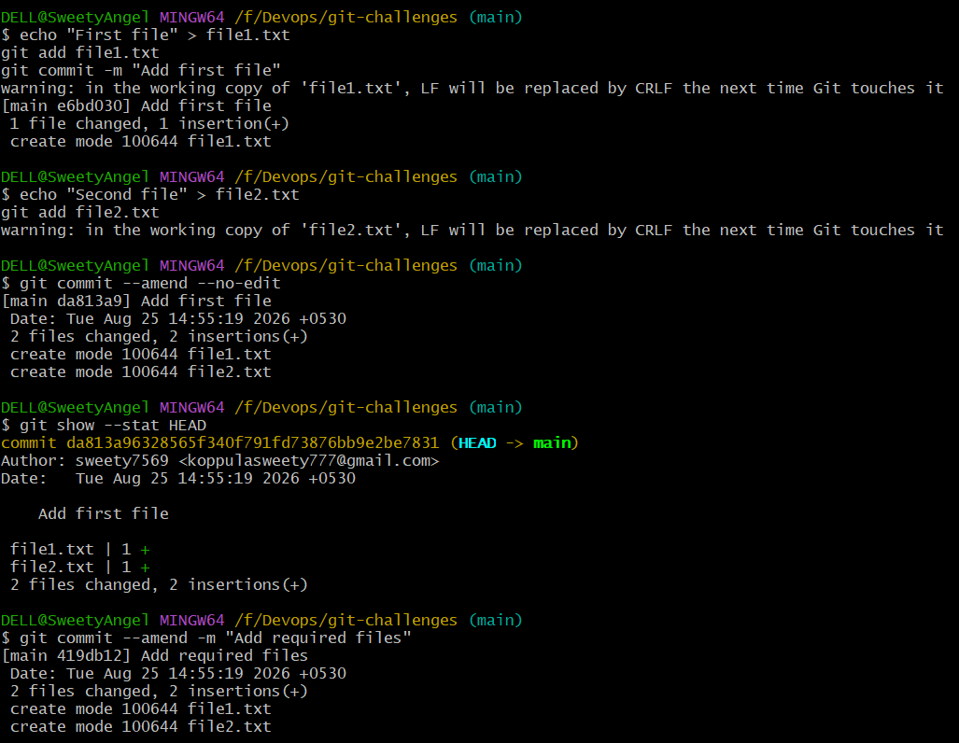
- Cherry-pick a Commit
  - Take a specific commit from one branch and apply it to another branch.
Create a branch:
git checkout -b feature
Make a commit:
echo "Cherry pick this" > cherry.txt
git add cherry.txt
git commit -m "Add cherry-pick example"
Find its commit ID:
git log --oneline
Example:
a1b2c3d Add cherry-pick example
Go to main:
git checkout main
Apply only that commit:
git cherry-pick a1b2c3d
Check:
git log --oneline
The change from the feature branch is now applied to main.
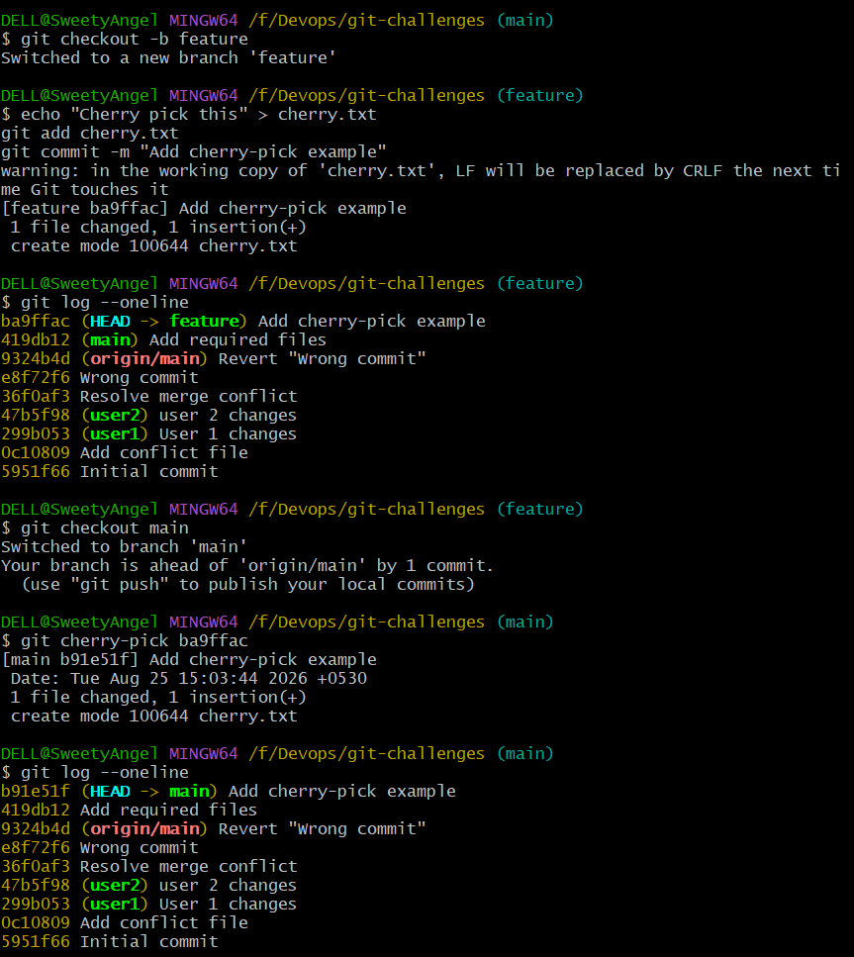

- Interactive Rebase
  - Reorder and squash multiple commits into a single clean commit.
Create three commits:
echo "Line 1" > rebase.txt
git add rebase.txt
git commit -m "Commit 1"

echo "Line 2" >> rebase.txt
git add rebase.txt
git commit -m "Commit 2"

echo "Line 3" >> rebase.txt
git add rebase.txt
git commit -m "Commit 3"
Check:
git log --oneline -3
Start interactive rebase:
git rebase -i HEAD~3
You'll see:
pick abc1111 Commit 1
pick abc2222 Commit 2
pick abc3333 Commit 3
To squash commits 2 and 3:
pick abc1111 Commit 1
squash abc2222 Commit 2
squash abc3333 Commit 3
Save and close.
Then check:
git log –oneline
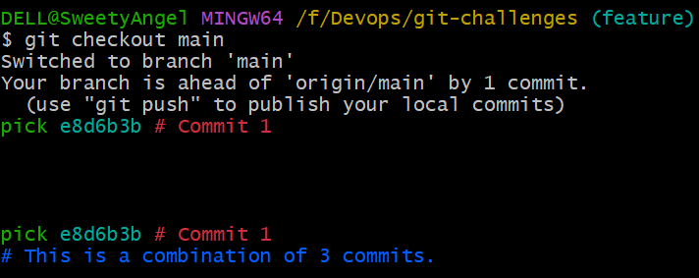

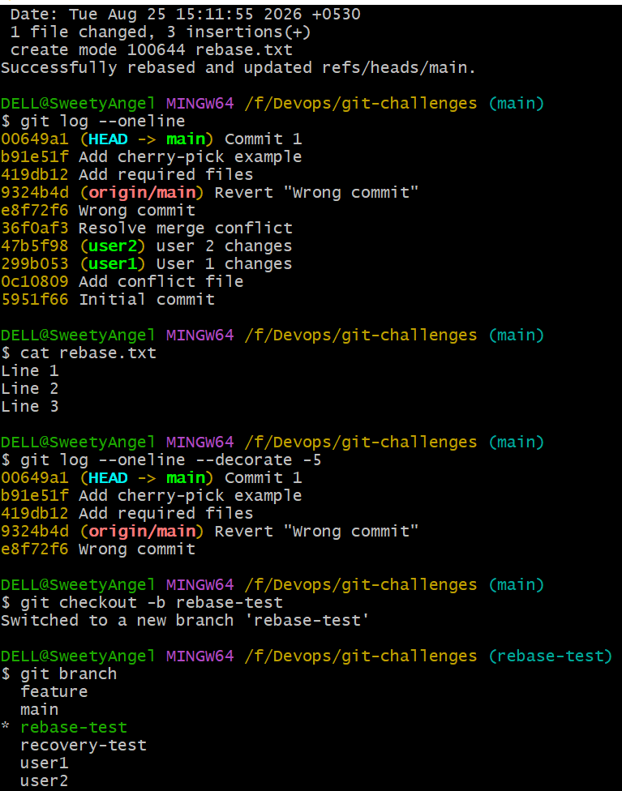

7.Tagging & Release
  - Create a version tag (v1.0), push it to GitHub, then delete and restore it.
Create a tag:
git tag v1.0
Check:
git tag
Push:
git push origin v1.0
Or push all tags:
git push origin --tags
Delete local tag
git tag -d v1.0
Delete remote tag
git push origin --delete v1.0
Restore tag
Find the commit:
git log --oneline
Create the tag again:
git tag v1.0 <commit-id>
Push:
git push origin v1.0
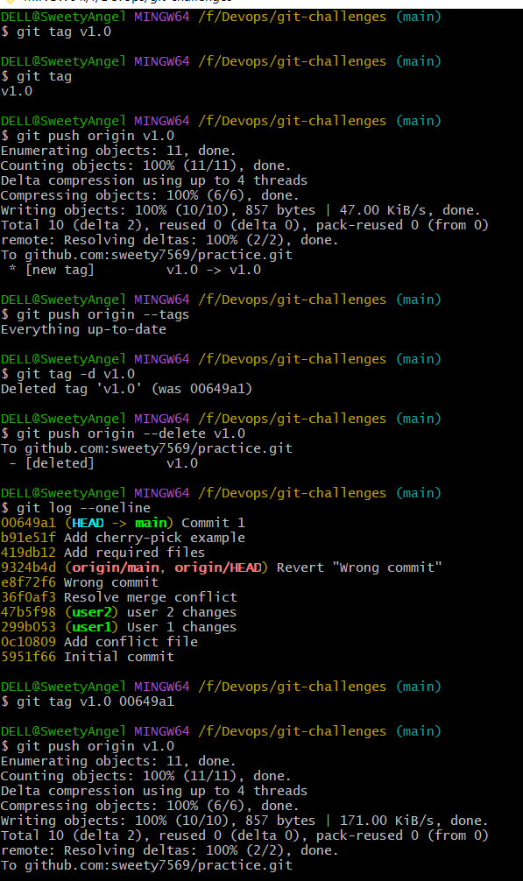

8.Clone with Sparse Checkout
  - Clone only a subdirectory of a repo using sparse checkout.
This is useful when you want only a specific directory from a large repository.
Clone without checking out everything:
git clone --no-checkout <REPOSITORY-URL>
cd <REPOSITORY-NAME>
Enable sparse checkout:
git sparse-checkout init --cone
Choose the directory:
git sparse-checkout set folder-name
For example:
git sparse-checkout set docs
Check:
ls
You should see only the selected directory and necessary Git files.
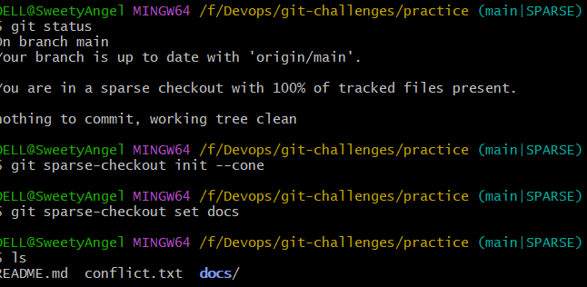
9. Reset vs Revert Challenge
  - Demonstrate the difference between git reset –hard and git revert in a repo.

This is an important interview/practical challenge.
Reset
Create a commit:
echo "Reset example" > reset.txt
git add reset.txt
git commit -m "Reset example"
Check:
git log --oneline
Reset:
git reset --hard HEAD~1
The commit is removed from the current branch history.
You can potentially recover it using:
git reflog

Revert
Create another commit:
echo "Revert example" > revert.txt
git add revert.txt
git commit -m "Revert example"
Instead of removing the commit:
git revert HEAD
Git creates a new commit that reverses the previous commit.
Main difference
Reset | Revert
Moves branch pointer | Creates a new commit
Can rewrite history | Preserves history
Common for local commits | Safe for pushed/shared commits
git reset | git revert

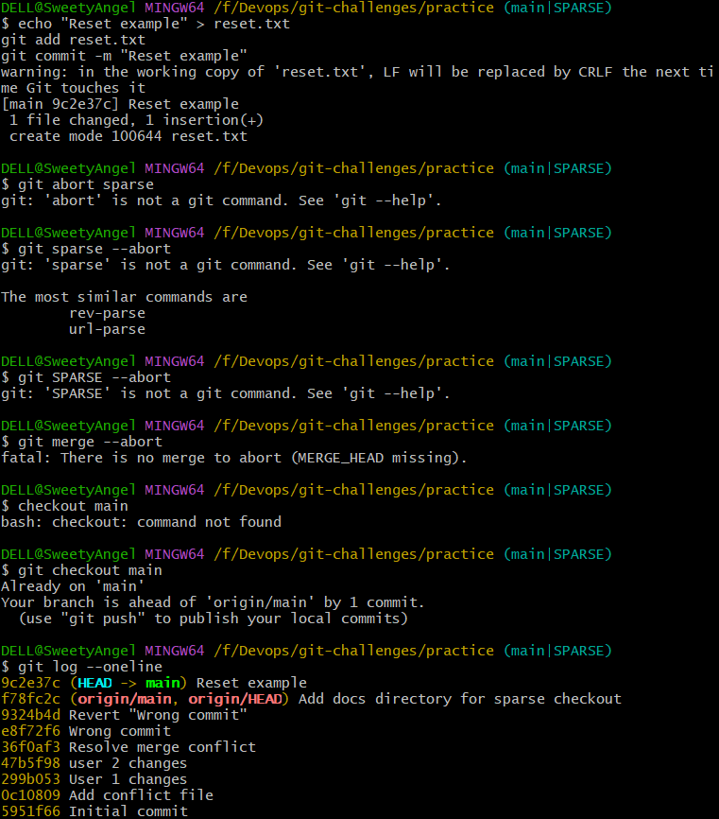

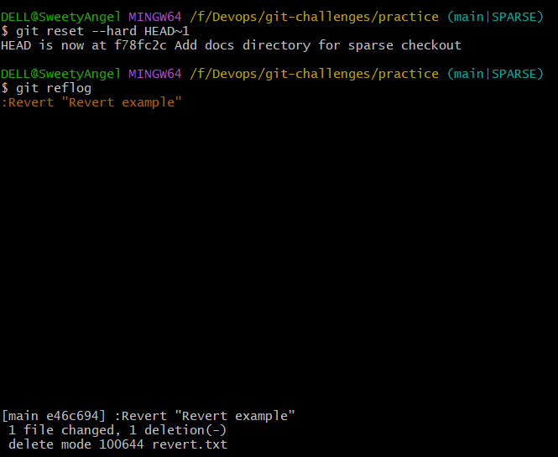
10. Detached HEAD Challenge
  - Checkout a specific commit (detached HEAD state) and create a new branch from it.
Find commits:
git log --oneline
Example:
abc1234 Third commit
def5678 Second commit
Checkout a specific commit:
git checkout def5678
Check:
git status
You'll see something similar to:
HEAD detached at def5678
Now create a branch from this point:
git checkout -b recovered-branch
Check:
git branch
You are now safely working on a branch.

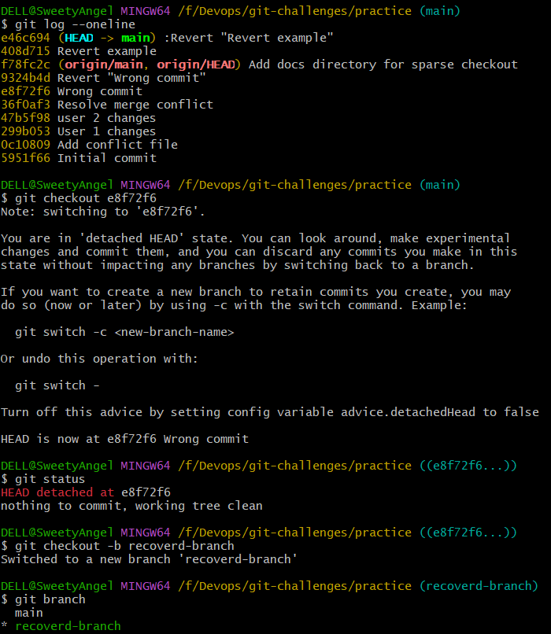

11. Git Hooks Challenge
  - Configure apre-commithook to reject commits without a message format (e.g., must start withJIRA-XXX).
Goal:
Commit message must start with JIRA-XXX.

For example:
JIRA-101 Fix login issue
Go to:
cd .git/hooks
Create the hook:
nano pre-commit
Put:
#!/bin/bash

message=$(git log -1 --pretty=%B)

if [[ ! "$message" =~ ^JIRA-[0-9]+ ]]; then
echo "ERROR: Commit message must start with JIRA-XXX"
exit 1
fi

exit 0
However, there is an important point: pre-commit runs before the commit message is created, so it is not the correct hook for validating the commit message.
Use:
commit-msg
instead.
Create:
nano commit-msg
Put:
#!/bin/bash

commit_msg_file="$1"
commit_msg=$(cat "$commit_msg_file")

if [[ ! "$commit_msg" =~ ^JIRA-[0-9]+ ]]; then
echo "ERROR: Commit message must start with JIRA-XXX"
exit 1
fi

exit 0
Make it executable:
chmod +x commit-msg
Now test:
git commit -m "Fix login"
It should reject the commit.
Try:
git commit -m "JIRA-101 Fix login"
It should allow the commit.

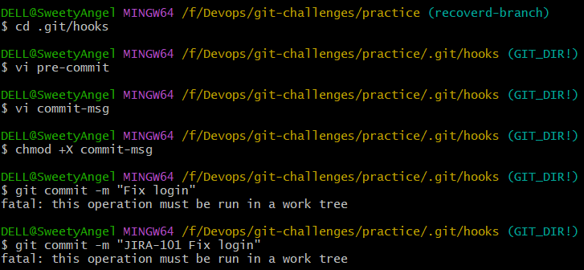
12. Squash Merge vs Rebase Merge
  - Show the difference between squash merge and rebase merge with evidence.
Create feature branch:
git checkout -b feature
Create two commits:
echo "Feature 1" > feature.txt
git add feature.txt
git commit -m "Feature commit 1"

echo "Feature 2" >> feature.txt
git add feature.txt
git commit -m "Feature commit 2"
Rebase merge
First rebase:
git checkout feature
git rebase main
Then:
git checkout main
git merge --ff-only feature
The feature commits remain as individual commits.
Squash merge
Create another feature branch:
git checkout main
git checkout -b feature-squash
Create multiple commits:
echo "Part 1" > squash.txt
git add squash.txt
git commit -m "Part 1"

echo "Part 2" >> squash.txt
git add squash.txt
git commit -m "Part 2"
Go to main:
git checkout main
Squash merge:
git merge --squash feature-squash
Then:
git commit -m "Add complete squash feature"
Difference
Rebase merge:
main
|
A---B---C
\
D---E
The feature commits remain separate.
Squash merge:
main
|
A---B---S
Multiple feature commits become one commit.
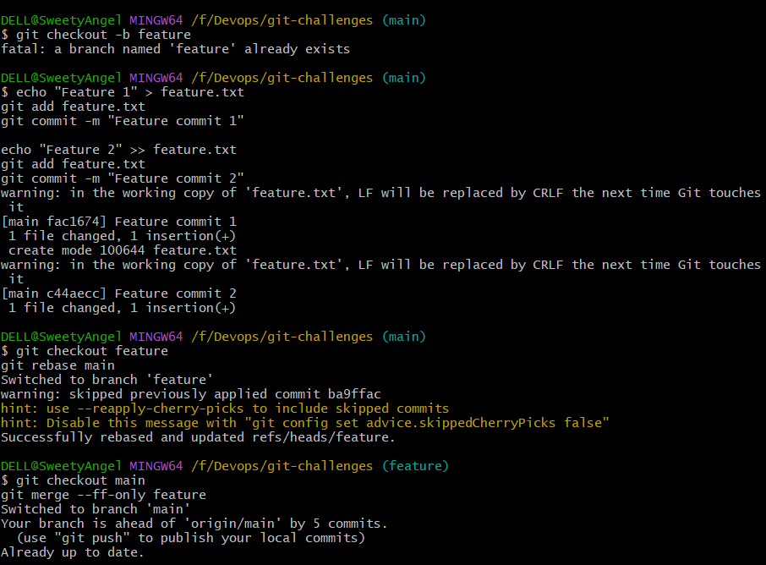
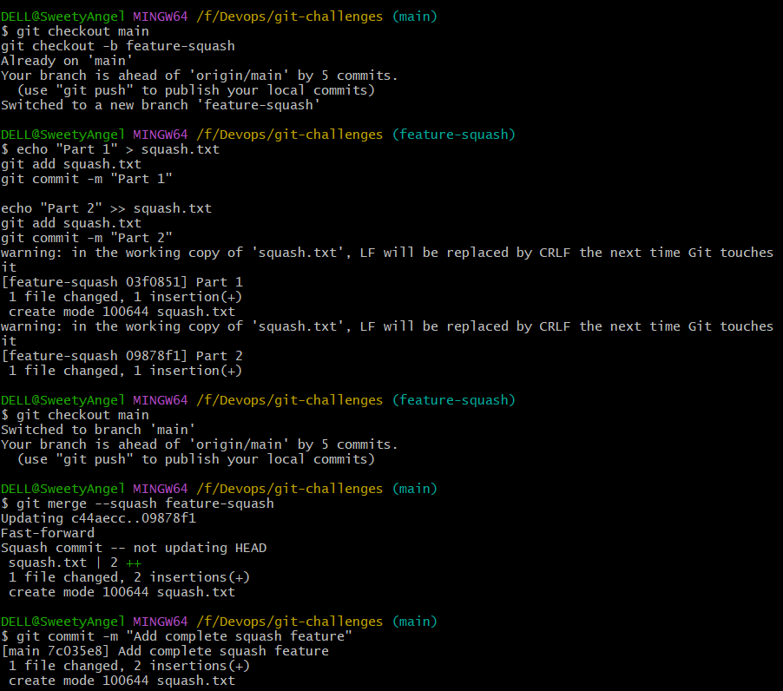

- Fork & Pull Request Workflow
  - Fork a repo, make a change, and submit a pull request to the original repo.
This one uses GitHub.
Step 1
Open a repository on GitHub.
Click:
Fork
Your account gets a copy of the repository.
Step 2: Clone your fork
git clone <YOUR-FORK-URL>
cd <REPOSITORY>
Step 3: Create a branch
git checkout -b my-change
Step 4: Make changes
echo "My contribution" >> README.md
git add README.md
git commit -m "Add my contribution"
Step 5: Push
git push origin my-change
Step 6
Go to GitHub.
You'll see:
Compare & pull request
Click it.
Select:
base repository: original repository
base branch: main

head repository: your fork
compare branch: my-change
Create the Pull Request.
The repository owner can then review and merge your changes.

- Recover Lost Commit
  - Commit something, reset hard, and then recover it usinggit reflog.
